STUDENT’S REPORT CARD



PROJECT REPORT

*Made by*

*Pushaan sharma(co19349) Arjun gupta(co19314) Prabhjot singh(co19346)*

ACKNOWLEDGEMENT



I would like to express my special thanks of gratitude to my teacher Dr. Sarabjeet Singh as well as our principal Dr.

Manpreet Singh Gujral who gave me the golden opportunity to do make this program on topic student’s report card, which also helped me in doing a lot of research and I came to know about so many new things I am really thankful to them.

Secondly i would also like to thank my parents and friends who helped me a lot in ﬁnalising this project within the limited time frame.

TABLE OF CONTENT



* Overview
* Execution of program
* How to create student record
* Checking the result
* Displaying all records
* Searching a student record
* Modifying a student record
* Result before and after modifying
* Deleting a record

OVERVIEW OF OUR PROGRAM



### The program made by our team is a database which stores and displays marks of students. It also helps in calculating the percentage and gives students the grades.

It also has options to edit the database for changing, modifying or deleting an entry.

It helps us to view the result of the whole at a time, view each and every student’s report card at a time, view report cards of all the students together.

EXECUTION OF PROGRAM

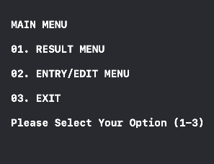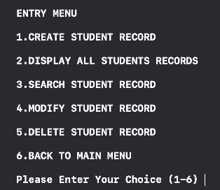

When we ﬁrst run the program, we are directed to a main menu which displays 3 options as shown in ﬁgure above, as we are running the program for the ﬁrst time, the result menu will be empty. So to enter roll number, name and marks of students, we have to enter 2 so that we get access entry/edit menu.

Then once we enter 2, we are directed to entry menu which displays 6 option to choose from that are given in the ﬁgure above. As we are running the program for the ﬁrst time, the all other options will give no result and take you to the main menu. So to start creating a database for maintaining record for students, we must enter 1 to create student record.

HOW TO CREATE A STUDE T RECORD

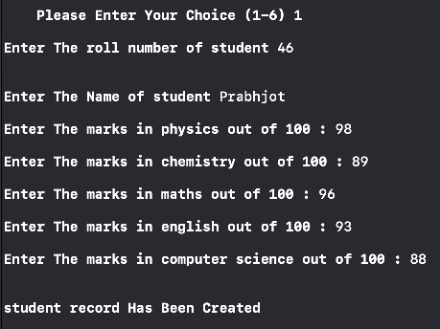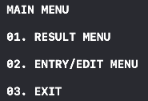

When we enter 1, we are directed to a window to enter student record. First we have to enter the roll number of the student, then the name, then marks of physics, chemistry, maths, English and computer science out of 100.

Then on pressing return key, we are again directed to the main menu.

Similarly by repeating above steps, we can generate record of as many students as we want. If we want to exit program, enter 3.

# CHECKING THE RESULT

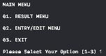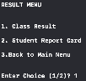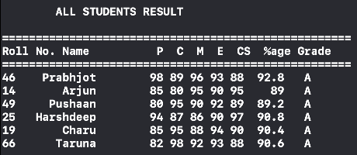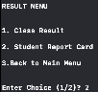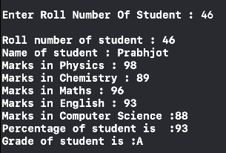

When we open result menu from main menu, we have 2 option; to see class result, enter 1; to see student report card, enter 2.

## DISPLAYING ALL RECORDS TOGETHER

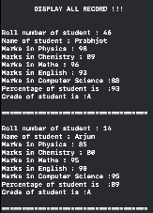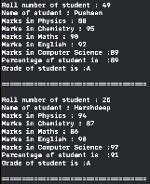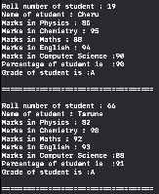

If we want to display all report cards together, enter 2 in Entry menu which will display the report cards of all the students together in a sequence.

SEARCHING A STUDENT RECORD

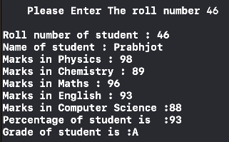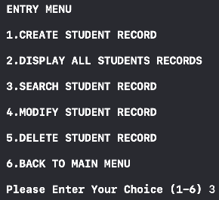

If we want to search a student record, enter 3 on Entry menu then program will ask the roll number of the student whose report card we want to view, after entering the roll number of the student, report card of that student will be displayed.

MODIFYING A STUDENT RECORD

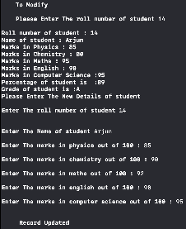

If we want to modify a record, enter 4 on Entry menu then program will ask the roll number of the student whose record we want to modify, after entering the roll number, program will display the previous record of that student and after that it will ask for new details of the student. We can either completely change the roll number, name of the student i.e. assign a complete new student at that space or just amend the marks of the same student.

For example, after rechecking of exams, marks of Arjun in chemistry increased by 10 and decreased by 3 in maths. So, to modify the marks in just 2 subjects, I entered 4 on the Enter menu, entered his roll number i.e. 14, entered all his same details but in chemistry and maths, added his new score i.e. 90 and 92 respectively.

RESULT B FO E AND AFT R MODIFYING

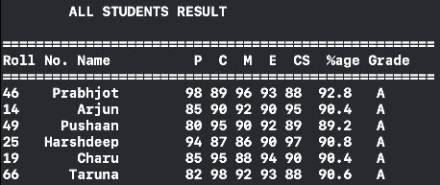

BEFORE MODIFYING

AFTER MODIFYING

DELETING A RECORD

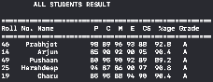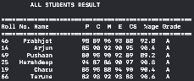

If we want to delete a record, enter 5 on Entry menu then program will ask the roll number of the student that we want to delete, after entering the roll number record will be deleted of that student.

AFTER DELETING BEFORE DELETING



THANK YOU